Welcome Students

Before we start, I would appreciate your sending me a private email
nholden@jewishgen.org
1. what do you want to accomplish?
2. who are your researching?
in other words names dates and places
- your person(s) of interest (surname)
- your person of interests given names
- your person of interests approximate dates
- Your person of interests place of birth or last residence

3. What brought you to a stopping place...or the reason you want to look for new solutions
in other words, what is your brick wall

4. What have you already done
- this can be broadly defined...like I searched all the census records for New York
- or detailed with the URL for example:
  - 1900 New York census +url;
  - 1920 New York Census+url

Please return before class starts so I can work ahead and help you make your plan.

-----------------------------------------------------------------------

When you are logging in for the first time, Here is what you need to know.

The website for this class is

https://www.jewishgen.org/EDUCATION/FORUM/brick-wall-or-dead-end-2026_forum1513.html
To Log In
Use your JewishGen ID Number

The password is the same for everyone It is the password

Aclass4Me

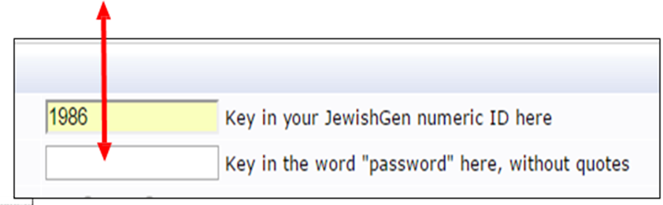

The Forum is open for you to look around and download materials.
- Read How to Use this Forum
There are special requirements for entering your search
- Read Your First Post for the Posting Requirements

- Read How to Use the Forum for what goes in the message box and how to Post your topic
- Read How to Use the Forum to EDIT as post.
- Posting Requirements – Your First Post. To begin you can enter your application data for the Introduction. You goal and objectives are the details we will work on together.
- Start you first post
Click on New Topic. Write your information.

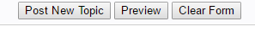
Post New Topic.
Once you click on Post your topic you will see your post in the INDEX. It appears with your name below my example.

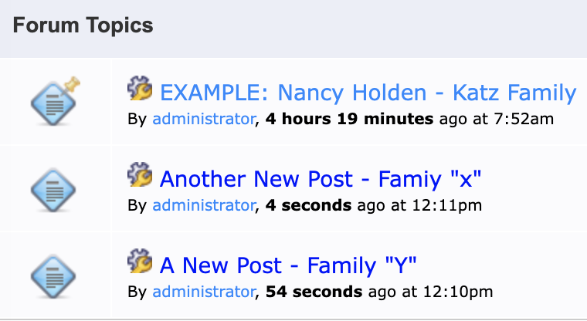

Posts move down when a new person posts. Look in the line of posts for your name.
Always post in the same place under your name.

Your Initial Post is the DATA BOARD also called Your First Post. You will be editing and re-editing your initial post as you find new information.
- I may ask you to abstract the census if you are working in the U.S. or if the census will move us out of the brick wall. The Census (See Posting Requirements)
- I may ask you to work with records in JewishGen.
- I may ask you to post an image of a record from JewishGen. To post an image please read the How to Use the Forum.
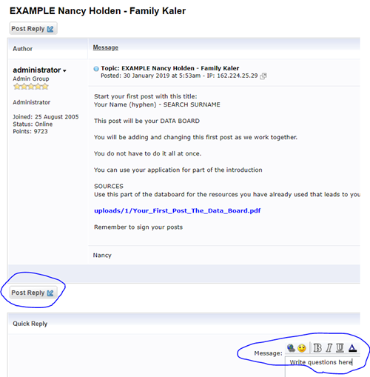
- If you have questions, please write them out in a new message below your “Student Post – Family Surname
- Your post should sign themselves....

See you in class Nancy Holden
27 September 2026

