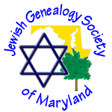JEWISH GENEALOGY SOCIETY OF MARYLAND

Meeting of August 16, 2015
1:30 – 3:00 pm
Hadassah of Greater Baltimore
3723 Old Court Road, #205
Pikesville, MD 21208

MINUTES

President Lara Diamond opened the meeting at 1:30 pm and welcomed everyone to our new meeting location. The Hadassah office will serve as our monthly meeting location throughout the 2015/ 2016 program year.
There were quite a few first time attendees and they were invited to introduce themselves. Most also said a little about the family research they were pursuing.
We had previously learned that JGSMD’s newsletter, L’dor V’dor, had been judged the best publication for 2015 by the IAJGS. In addition to earlier acknowledgement of the exceptional work of our editor, Sue Steeble, our local society received a plaque to commemorate the achievement.
We learned that Robin Thomas, our treasurer, will be stepping down and we will need to fill that board office. The treasurer’s report noted that we now have 110 paid members and a balance in our checking account of $2,700. Also noted was a donation from the Jewish Museum of Maryland.
Lara then introduced our guest speaker, Israel Pickholtz, visiting from his home base in Jerusalem. Mr. Pickholtz has recently published his book, “Endogamy: One Family, One People” and has been traveling in the United States in recent weeks, meeting with societies such as ours. The book is an outgrowth of his own research into family history and he now explains to his audiences the relevance of Genetic Genealogy to Jewish family research.

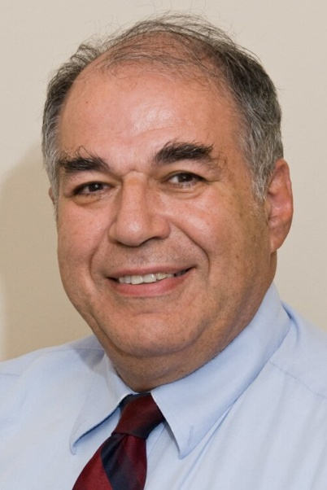  Israel Pickholtz  Genealogist  Jerusalem, Israel  Author,  Endogamy: One Family, One People | Israel Pickholtz began researching his own Pickholtz family history about 20 years ago. In what he has named the Pikholz Project, he has identified two distinct branches of the family, one from Skalat and the other from Rozdol, both in eastern Galicia.  Pickholtz has been involved in Genetic Genealogy since 2012. He indicated that Jewish family genetic history is particularly challenging, because of practices in earlier times that encouraged cousin marriages. As we trace back to earlier generations we encounter “pedigree collapse,” which in genetic studies is termed endogamy.  Still, Pickholtz encourages DNA testing, just requiring a cheek swab, to enhance the possibility of finding new matches to individuals on one’s own family tree. He explained three distinct types of genetic studies: 1) Y chromosome, 2) Mitochondrial (Mt) and 3) Autosomal “family finder.” Beyond his recently published book, Pickholtz blogs at allmyforeparents.blogspot.com.  Mr. Pickholtz’s presentation sparked many questions from those in attendance, several of whom had already delved into genetic genealogy.

Next Meeting

The next program will take place on September 20 at 1:30PM at our new location for 2015-2016, the local Hadassah office. The program will consist of our second annual “Show and Tell.” Members are invited to bring in one item (artifacts, documents, photographs or other items relating to their family histories) and to say a few words about it.
Top of Form

