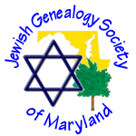JEWISH GENEALOGY SOCIETY OF MARYLAND

Meeting of March 22, 2015
1:30 – 3:00 pm
Pikesville Branch, Baltimore County Library

MINUTES

President Lara Diamond opened the meeting at 1:30 pm. New members were invited to introduce themselves.
Vice President Dick Goldman announced that, beginning in April, he will be teaching several genealogy classes at CCBC (Hunt Valley and Owings Mills campuses) and at the JCC in Owings Mills. These are all daytime classes, but he offered to give an evening class also, if there is sufficient interest.
Publications chair Susan Steeble thanked members for responding to her “call for articles” for the April 1 newsletter and encouraged members to continue submitting articles for future issues.
Treasurer Robin Thomas announced that a new member, Eileen Rosenbaum, has become our 100th paid member.
Minna Culiner spoke about a research study on a mutation in the LRRK2 gene that may be associated with Parkinson’s disease in people with Ashkenazi Jewish ancestry. The project is seeking volunteers; criteria for participation are described in the flyer that Minna distributed.
Lara mentioned her plans to attend (and speak at) the International Association of Jewish Genealogy Societies (IAJGS) conference in Jerusalem. She will travel via Ukraine Air and will extend her trip with a 4-day visit to three of her ancestral towns in Ukraine.

Featured Presentation

Lara then introduced the guest speaker. Mr. Ken Bravo, who is a past president of the Jewish Genealogy Society of Cleveland, currently serves as a Vice President of the IAJGS.

Ken Bravo  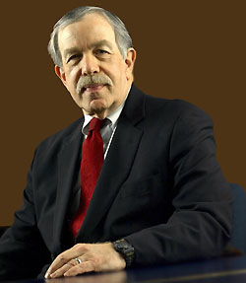  Vice President, IAJGS | In Mr. Bravo’s presentation, “Why The New York Times Is Wrong—Using Basic Genealogical Tools to Show That Your Family Name Was Not Changed at Ellis Island,” he described how he had proved that the common saying that an immigrant’s name was “changed at Ellis Island” is a myth. In European ports of departure, the ship company clerks recorded the names given on the identification papers presented by the immigrants; at Ellis Island, as passengers arrived, the clerks  simply checked off the names that were already written on the manifests—they did not change the names!  To prove his point to the NY Times, Ken researched the subjects of several newspaper obituaries and examined the passenger manifests, naturalization documents, censuses, and other records to discover the person’s original family name and to determine the point at which a shortened or completely different name was recorded. The presentation included a PowerPoint demonstration of his methodical, step-by-step process—which would be applicable to almost any genealogical quest.

Next Meeting
Lara announced that the April 26 program would be given by Ava Cohn, a.k.a. Sherlock Cohn, the Photo Genealogist. Members are invited to bring one photo for Ava to analyze after the program.
The meeting adjourned at about 3:15 p.m.

Top of Form

